***PAAREES PERFUMES***

***THIERRY MUGLER***

***FOR MEN***

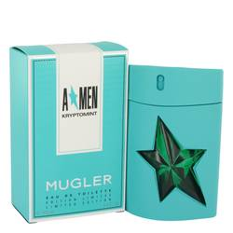

# 

***ANGEL KRYPTOMINT***

## *Description:*

Angel Kryptomint by Thierry Mugler Cologne. For the refined gentleman looking to make a bold style statement, a spritz of Angel Kryptomint will give you a splash of cool. Layered accords of greens, spices and a hint of sweetness make this long-lasting cologne suitable for everyday use. Fresh, herbal top notes of mint and sage begin the scent profile before moving on to a floral heart of geranium. A sultry base of chocolate, tonka bean, vanilla, coffee and patchouli will have you sniffing your wrist long into the night. Launched in 2017 as a limited edition, this 3.4-ounce eau de toilette spray comes packaged in a striking green flacon featuring a star-shaped green gem.